**Exercise 1: Configuring a Basic Spring Application**

**Add Spring Core Dependency**

<project xmlns="http://maven.apache.org/POM/4.0.0"

xmlns:xsi="http://www.w3.org/2001/XMLSchema-instance"

xsi:schemaLocation="http://maven.apache.org/POM/4.0.0

http://maven.apache.org/xsd/maven-4.0.0.xsd">

<modelVersion>4.0.0</modelVersion>

<groupId>com.library</groupId>

<artifactId>LibraryManagement</artifactId>

<version>1.0-SNAPSHOT</version>

<dependencies>

<dependency>

<groupId>org.springframework</groupId>

<artifactId>spring-context</artifactId>

<version>5.3.34</version>

</dependency>

</dependencies>

</project>

**BookRepository.java**

package com.library.repository;

public class BookRepository {

public void displayBookInfo() {

System.out.println("Fetching book information from the database...");

}

}

**BookService.java**

package com.library.service;

import com.library.repository.BookRepository;

public class BookService {

private BookRepository bookRepository;

public void setBookRepository(BookRepository bookRepository) {

this.bookRepository = bookRepository;

}

public void showBooks() {

bookRepository.displayBookInfo();

}

}

**Configure Spring Beans in XML**

<?xml version="1.0" encoding="UTF-8"?>

<beans xmlns="http://www.springframework.org/schema/beans"

xmlns:xsi="http://www.w3.org/2001/XMLSchema-instance"

xsi:schemaLocation="http://www.springframework.org/schema/beans

http://www.springframework.org/schema/beans/spring-beans.xsd">

<bean id="bookRepository" class="com.library.repository.BookRepository" />

<bean id="bookService" class="com.library.service.BookService">

<property name="bookRepository" ref="bookRepository" />

</bean>

</beans>

**MainApp.java**

package com.library.main;

import com.library.service.BookService;

import org.springframework.context.ApplicationContext;

import org.springframework.context.support.ClassPathXmlApplicationContext;

public class MainApp {

public static void main(String[] args) {

ApplicationContext context = new ClassPathXmlApplicationContext("applicationContext.xml");

BookService bookService = context.getBean("bookService", BookService.class);

bookService.showBooks();

}

}

**OUTPUT**

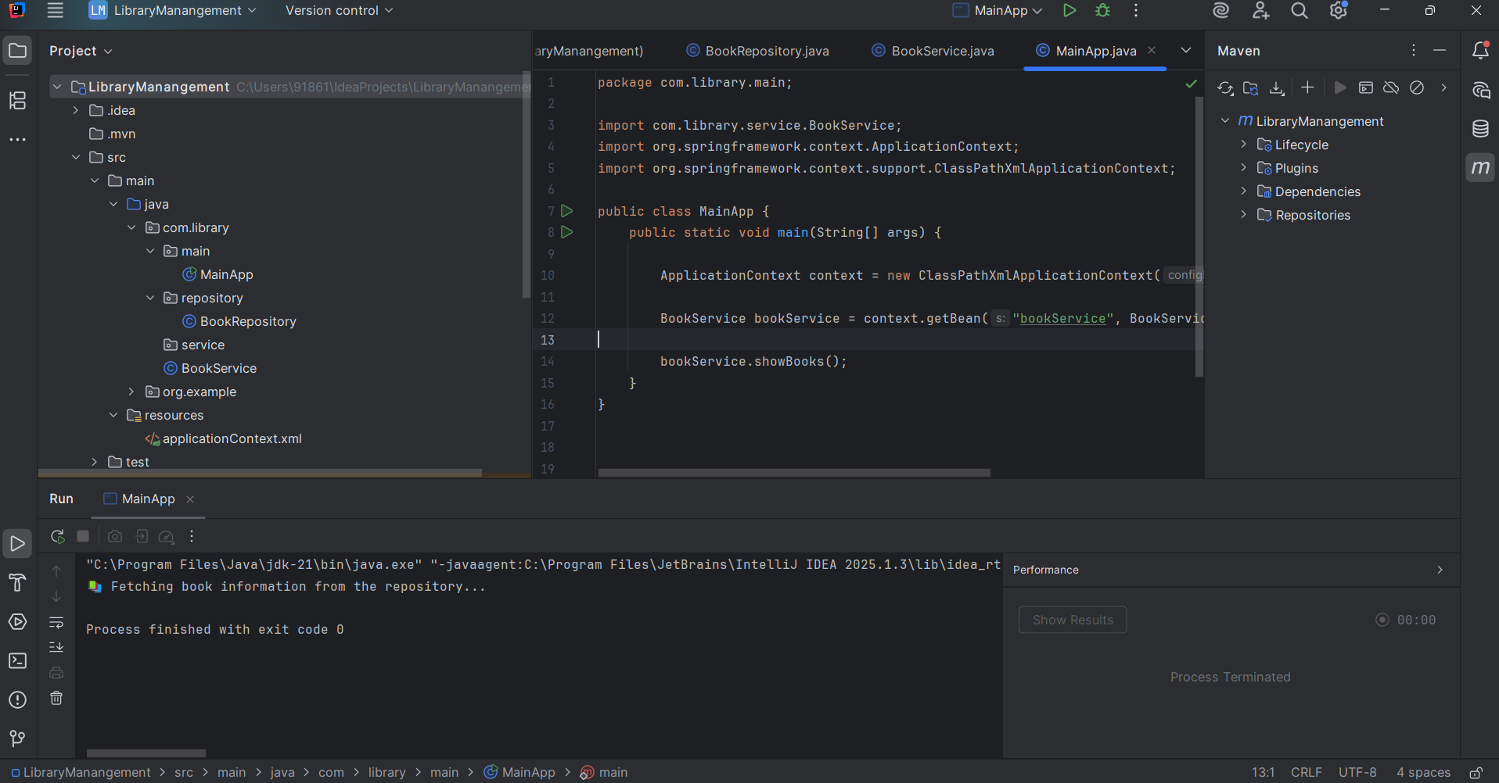

**Exercise 2: Implementing Dependency Injection**

**XML Configuration**

<?xml version="1.0" encoding="UTF-8"?>

<beans xmlns="http://www.springframework.org/schema/beans"

xmlns:xsi="http://www.w3.org/2001/XMLSchema-instance"

xsi:schemaLocation="http://www.springframework.org/schema/beans

http://www.springframework.org/schema/beans/spring-beans.xsd">

<!-- BookRepository bean -->

<bean id="bookRepository" class="com.library.repository.BookRepository"/>

<!-- BookService bean with Dependency Injection -->

<bean id="bookService" class="com.library.service.BookService">

<property name="bookRepository" ref="bookRepository"/>

</bean>

</beans>

**BookService.java**

package com.library.service;

import com.library.repository.BookRepository;

public class BookService {

private BookRepository bookRepository;

public void setBookRepository(BookRepository bookRepository) {

this.bookRepository = bookRepository;

}

public void showBooks() {

bookRepository.displayBookInfo();

}

}

**MainApp.java**

package com.library.main;

import com.library.service.BookService;

import org.springframework.context.ApplicationContext;

import org.springframework.context.support.ClassPathXmlApplicationContext;

public class MainApp {

public static void main(String[] args) {

ApplicationContext context = new ClassPathXmlApplicationContext("applicationContext.xml");

BookService bookService = context.getBean("bookService", BookService.class);

bookService.showBooks();

}

}

**OUTPUT**

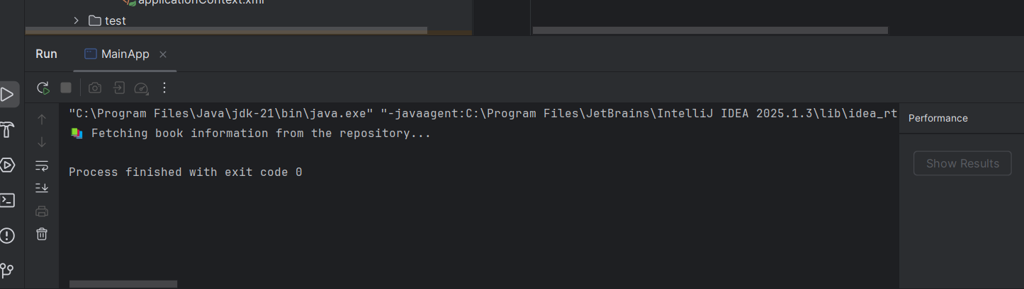

**Exercise 4: Creating and Configuring a Maven Project**

**pom.xml**

<?xml version="1.0" encoding="UTF-8"?>

<project xmlns="http://maven.apache.org/POM/4.0.0"

xmlns:xsi="http://www.w3.org/2001/XMLSchema-instance"

xsi:schemaLocation="http://maven.apache.org/POM/4.0.0 http://maven.apache.org/xsd/maven-4.0.0.xsd">

<modelVersion>4.0.0</modelVersion>

<groupId>com.library</groupId>

<artifactId>LibraryManagement</artifactId>

<version>1.0-SNAPSHOT</version>

<properties>

<maven.compiler.source>1.8</maven.compiler.source>

<maven.compiler.target>1.8</maven.compiler.target>

</properties>

<dependencies>

<!-- Spring Core + Context -->

<dependency>

<groupId>org.springframework</groupId>

<artifactId>spring-context</artifactId>

<version>5.3.34</version>

</dependency>

<!-- Spring AOP -->

<dependency>

<groupId>org.springframework</groupId>

<artifactId>spring-aop</artifactId>

<version>5.3.34</version>

</dependency>

<!-- Spring Web MVC -->

<dependency>

<groupId>org.springframework</groupId>

<artifactId>spring-webmvc</artifactId>

<version>5.3.34</version>

</dependency>

</dependencies>

<build>

<plugins>

<!-- Maven Compiler Plugin for Java 1.8 -->

<plugin>

<groupId>org.apache.maven.plugins</groupId>

<artifactId>maven-compiler-plugin</artifactId>

<version>3.10.1</version>

<configuration>

<source>1.8</source>

<target>1.8</target>

</configuration>

</plugin>

</plugins>

</build>

</project>

**HelloController.java**

package com.library.controller;

import org.springframework.stereotype.Controller;

import org.springframework.ui.Model;

import org.springframework.web.bind.annotation.GetMapping;

@Controller

public class HelloController {

@GetMapping("/hello")

public String sayHello(Model model) {

model.addAttribute("message", "Welcome to Spring MVC, Affu! ");

return "hello"; // this will map to hello.jsp

}

}

**web.xml**

<?xml version="1.0" encoding="UTF-8"?>

<web-app xmlns="http://xmlns.jcp.org/xml/ns/javaee"

xmlns:xsi="http://www.w3.org/2001/XMLSchema-instance"

xsi:schemaLocation="http://xmlns.jcp.org/xml/ns/javaee

http://xmlns.jcp.org/xml/ns/javaee/web-app_3_1.xsd"

version="3.1">

<servlet>

<servlet-name>spring</servlet-name>

<servlet-class>org.springframework.web.servlet.DispatcherServlet</servlet-class>

<init-param>

<param-name>contextConfigLocation</param-name>

<param-value>/WEB-INF/spring-servlet.xml</param-value>

</init-param>

<load-on-startup>1</load-on-startup>

</servlet>

<servlet-mapping>

<servlet-name>spring</servlet-name>

<url-pattern>/</url-pattern>

</servlet-mapping>

</web-app>

**spring-servlet.xml**

<?xml version="1.0" encoding="UTF-8"?>

<beans xmlns="http://www.springframework.org/schema/beans"

xmlns:mvc="http://www.springframework.org/schema/mvc"

xmlns:context="http://www.springframework.org/schema/context"

xmlns:xsi="http://www.w3.org/2001/XMLSchema-instance"

xsi:schemaLocation="

http://www.springframework.org/schema/beans

http://www.springframework.org/schema/beans/spring-beans.xsd

http://www.springframework.org/schema/context

http://www.springframework.org/schema/context/spring-context.xsd

http://www.springframework.org/schema/mvc

http://www.springframework.org/schema/mvc/spring-mvc.xsd">

<context:component-scan base-package="com.library.controller"/>

<mvc:annotation-driven/>

<bean class="org.springframework.web.servlet.view.InternalResourceViewResolver">

<property name="prefix" value="/WEB-INF/views/"/>

<property name="suffix" value=".jsp"/>

</bean>

</beans>

**hello.jsp**

<%@ page contentType="text/html;charset=UTF-8" %>

<html>

<head><title>Hello</title></head>

<body>

<h2>${message}</h2>

</body>

</html>

**OUTPUT:**

